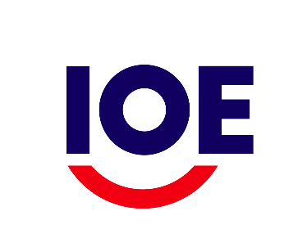 | West & Central Africa Employers’ Organisations Conference  Conakry, Guinea  12 – 13 December 2018
REGISTRATION FORM
I would like to receive an official invitation to attend the Conference.
I would like to request financial support (circle one): Yes No

Name
Organisation
Country

City of departure
Date of departure
City of arrival
Date of return

Date (Day/Month/Year): _____________________________
Please complete and return this registration form by email to Ms Caroline Balikungeri, IOE-EU Project Officer at balikungeri@ioe-emp.com

